Maternal and Child health (MCH)- Community Medicine- First Semester 2021-2022
Violence Against Women (VAW)

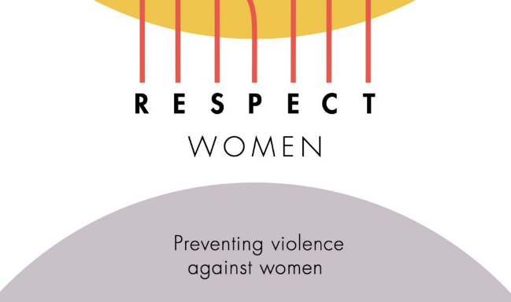

- Watch the video provided to answer the following question:
- What does R,E,S,P,E,C,T stands for in the RESPECT women framework?

- Use the reading provided to answer the following questions:
- What is the definition of IPV?
- Why don’t women leave violent partners?
- Explain relationship factors for IPV?
- What is the effect of IPV on children?
- Mention three steps related to reforming legal frameworks to deal with IPV?

